January Patient Group Meeting
Monday 12th January 2026
5.30 pm – 6:30 pm

Attendees:
- Shelby Preston Morris (SPM) – WGFHC Assistant Practice Manager
- Core Members – JB, SS, JT, WR, MW
- Apologies – SHE, PL, DP, KA, JC, BC

Actions from Monday 15 September 2025

National Patient Survey Results | SPM to produce an overview of the last 5 years.  Unfortunately, this wasn’t possible. Data only covers the past 2 years  Discussed and agreed that new data will be released, so SPM will compile this ready for the next meeting in March 2026
Contractual Changes | PPG members asked how these changes have affected practice staff and patients. SPM explained that there has been an increase in telephone calls over the lunch period; however, this is currently manageable.  SPM also explained that a doorbell has been installed inside the practice doors for patients who need to access the practice between 6:00 pm and 6:30 pm.  From April 2026, the practice will be open from 8:00 am to 6:30 pm, as the contract with the ambulance service covering the telephone service will come to an end.  Any further updates from the ICB will be shared with staff and members once received.

Agenda Item | Discussion points | Minutes/Actions
Winter Pressure Support Programme | This work is specifically aimed at preventing hospital admissions, working alongside existing services.  - GP-led respiratory illness clinic  - New, acute, or complex respiratory presentations  - 10 patients per session  - 1 session per practice  - GP (diagnosis and immediate treatment)  Deadline March 2026 | The Winter Pressure Programme was discussed. This initiative was introduced in 2025, and this year the PCN is supporting practices in achieving their targets. WGFHC will begin delivering this service next week.  SPM will submit the proposed clinic schedule to the PCN Manager following the Partners’ meeting.
Flu Season | 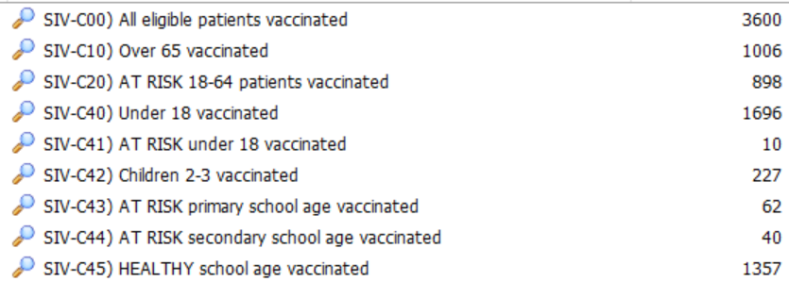 | The flu season was a success. The collaboration with the Ahmadiyya Centre worked extremely well, with the first weekend achieving the highest turnout ever. The practice will look at adopting a similar approach for the 2026/2027 flu season.
Reception recruitment | Successful!!  We are pleased to welcome Natasha to the WGFHC team. | Discussed, no action required
Patient DNA’s | 1106 missed appointments since April 2025. | Since April 2025, a total of 1,106 patients have not attended their appointments. We discussed that patients receive text reminders, which include a number to call if they are unable to attend. Unfortunately, despite this, we continue to have a high number of DNAs and would like to strengthen our processes.  SPM will raise this at the upcoming Partners’ meeting and propose the following approach:  - A text message to inform the patient they have DNA’d, including details of the DNA process.  - A letter following a second DNA, outlining the process again.  - After a third DNA, the case will be forwarded to the Partners to decide whether the patient should remain registered with the practice.  Members also suggested including information on the cost to the practice of each missed appointment.  The PPG members are in favour of this approach and hope the Partners will consider these suggestions.
AOB |  | Agreed on dates for future meetings  - 23rd March 2026  - 6th July 2026  - 28th September 2026  - 23 November 2026

